# Crazy Eater

## Description

This is a game in which the goal is to get as high of a level as you can before getting a game over.  
You start off playing in a space ship which is controlled by your mouse. The spaceship constantly follows your cursor.  
The game is pretty simple:  
• Avoid the Enemies  
• Collect the Boxes

If you get hit by enemies you will lose health (pink circles in the top left corner)  
If you lose all your health it's game over.

When you collect enough boxes you will get to a higher level.  
Each level slightly changes the gameplay.

Once you get to level 2, you might start seeing little PowerUps (Small Purple Squares).  
These PowerUps give random effects that might be good or bad.

## Design

The game is designed by using seperate classes for enemies, boxes, the player, and powerups.  
These objects have a few properties (Size, Position, Speed…).  
Some of these properties are used only to describe how the object should look on screen, others are used as variables that change during gameplay.  
All of the objects interact with each other through a single scene class, through which everything is drawn.

## Function Design

The scene class contains a function called “Collect()”. This function is called extremely often and what it does is run a check whether the player has collided with a box. It does this by checking the the horizontal and vertical distances of the 2 objects and comparing them to their sizes. If a collision occurs, the appropriate number of points are then added to the level counter.

## Screenshots

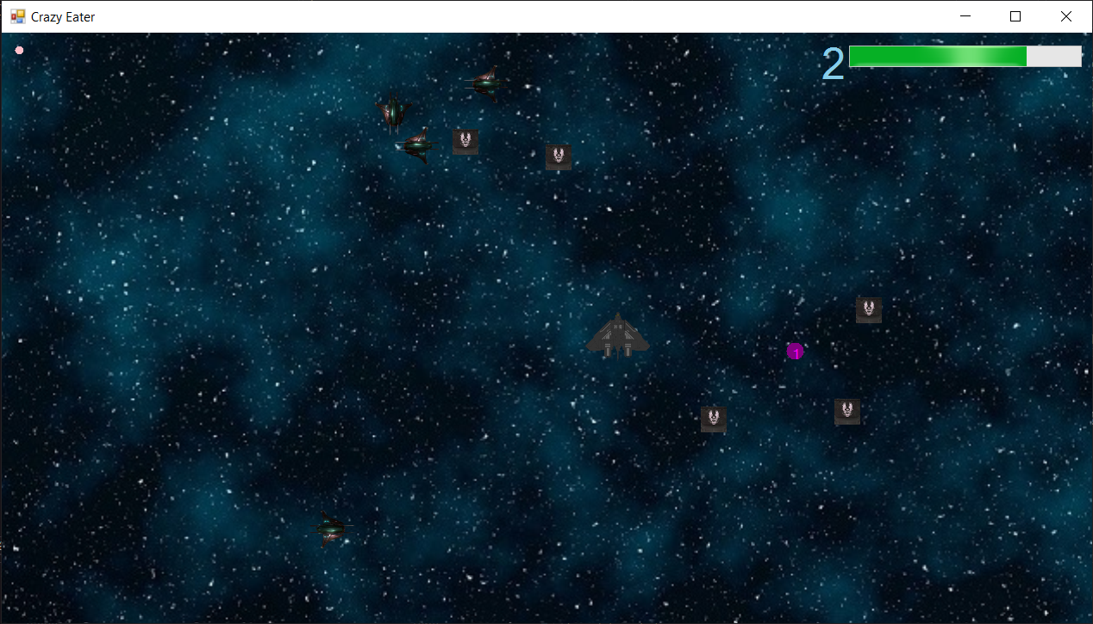

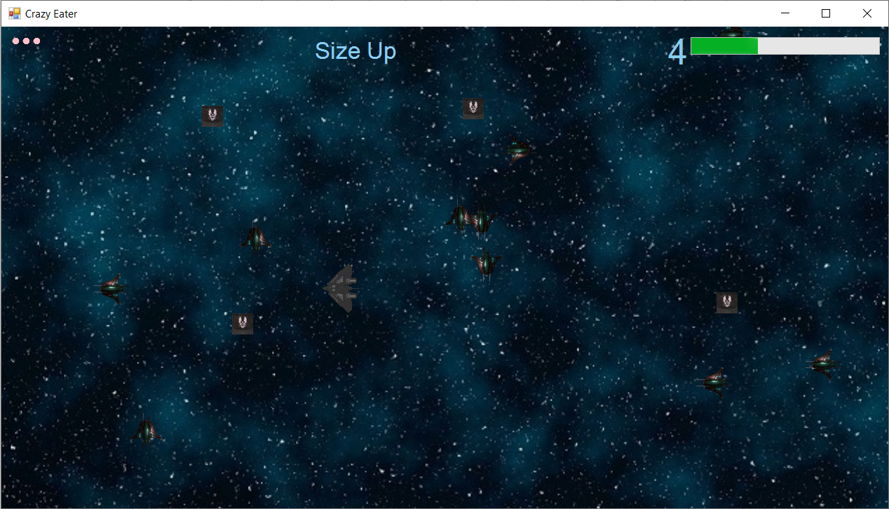

### 

### Some Background Information

Level Changes:  
**- Each Level gives +1 Health**  
**- Level 2:**  
• powerups now spawn  
• more obstacles  
• faster obstacles  
**- Level 3:**  
• more powerups  
• more obstacles  
• smaller player  
**- Level 4:**  
• more powerups  
• more obstacles  
• faster player  
**- Level 5:**  
• more obstacles  
• faster obstacles  
**- Level 6+:**  
• random amount of obstacles  
• random obstacle size  
• random obstacle speed  
• random player size  
• random player speed

PowerUps:  
**- Level 2**  
1 - Health Up  
2 - Speed Up  
3 - Size Up  
**- Level 3**  
4 - Speed Down  
5 - Size Down  
6 - Double Points  
**- Level 4**  
7 - Make the player look like an obstacle  
8 - Reverse Controls  
**- Level 5+**  
9 - Swap Obstacles & Collectables  
10 - Laser?